TRINITY PRIMARY SCHOOL- BUKOTO
REVISION WORK
CLASS: P.1
SUBJECT: ENGLISH
NAME: ____________________________ STREAM: __________
- Name these objects.
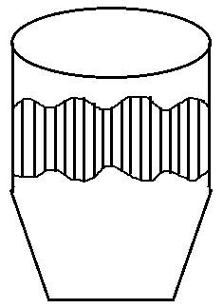 | 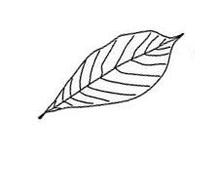 | 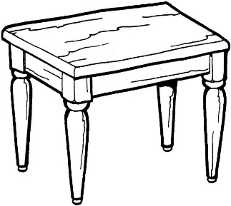 | 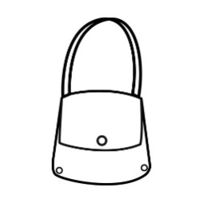

- Make sentences using; This is a…………………………
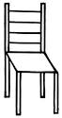_______________________________________________________
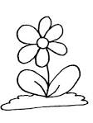_________________________________________________________

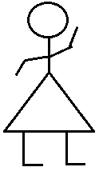________________________________________________________
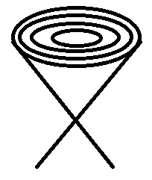

_____________________________________________________

- Write these words in small letters.
- HEN ______________________
- MAN ____________________
- KNIFE _____________________
- SUN _______________________

- Count and write in words.
- 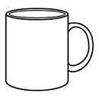_______________________ cups
- _______________________ eggs
- _______________________ chairs
- 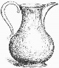 _______________________ tins
- Underline the correct spelling.
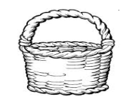 beskat basket ketbas
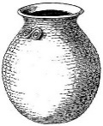 top opt pot
- Circle the odd man out.
- dress, pen, skirt, shirt
- green, yellow, blue, stone
- sun, moon, axe, stars

- Read and draw.
The children are playing | The girl is dancing
- Read and draw.
- The flower is in the pot

- I can see a hut

- The cat is under the table

- Children are playing

- Study the pictures and answer the questions.
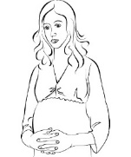
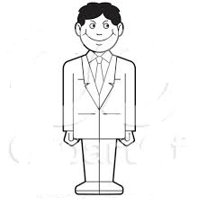
Mr Kasujja Mrs Kasujja

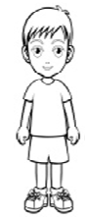Kalungi 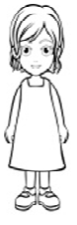Nakayiza Nagayi
Questions
- Who is the father?
_________________________________________________________
- Who is the mother?
_________________________________________________________
- Who is the son?
_________________________________________________________
- How many daughters does Mr Kasujja have?
_________________________________________________________
- What type of family is this? (extended, nuclear)
_________________________________________________________

End

